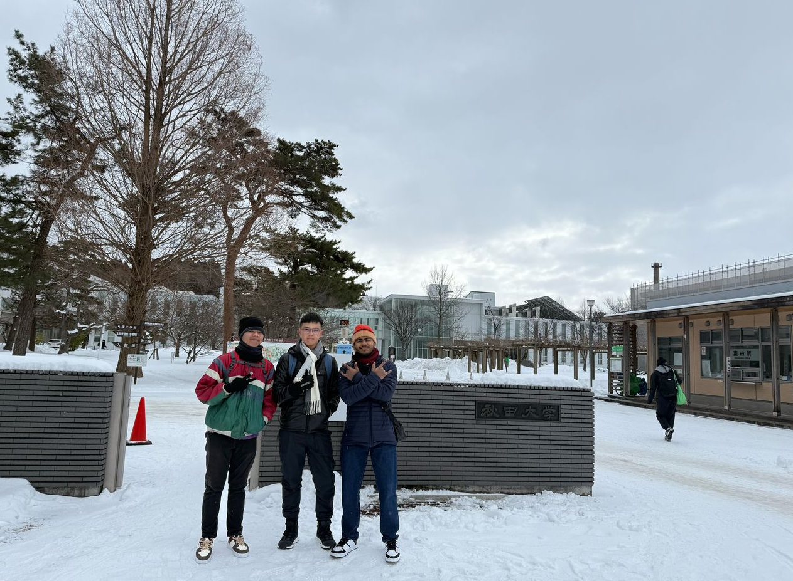
At Akita University

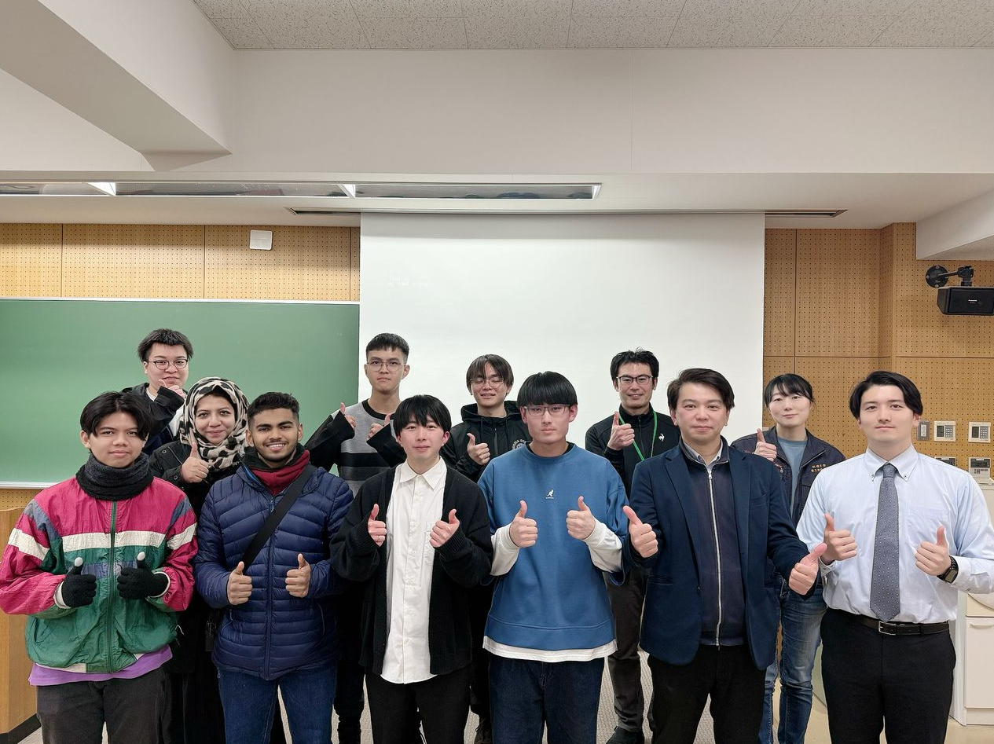
Introduction of Aircraft Electrification from IHI and students at Akita University

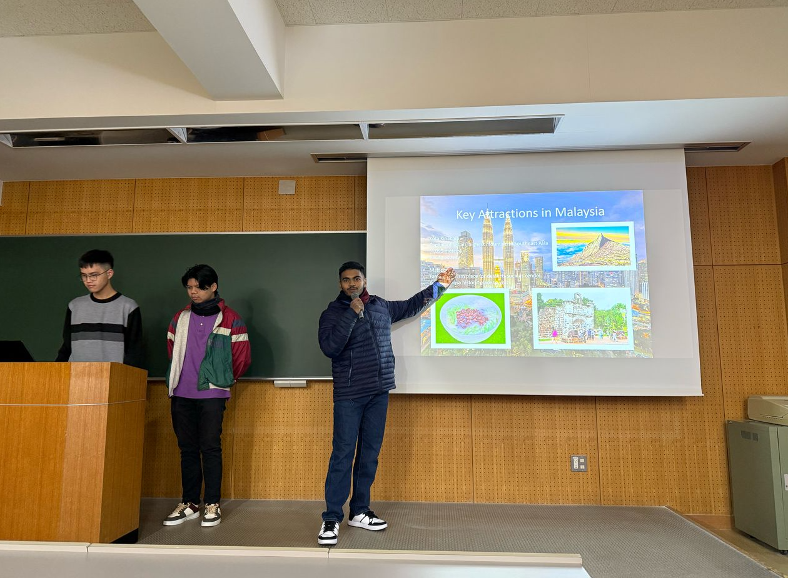
Students sharing about Malaysia

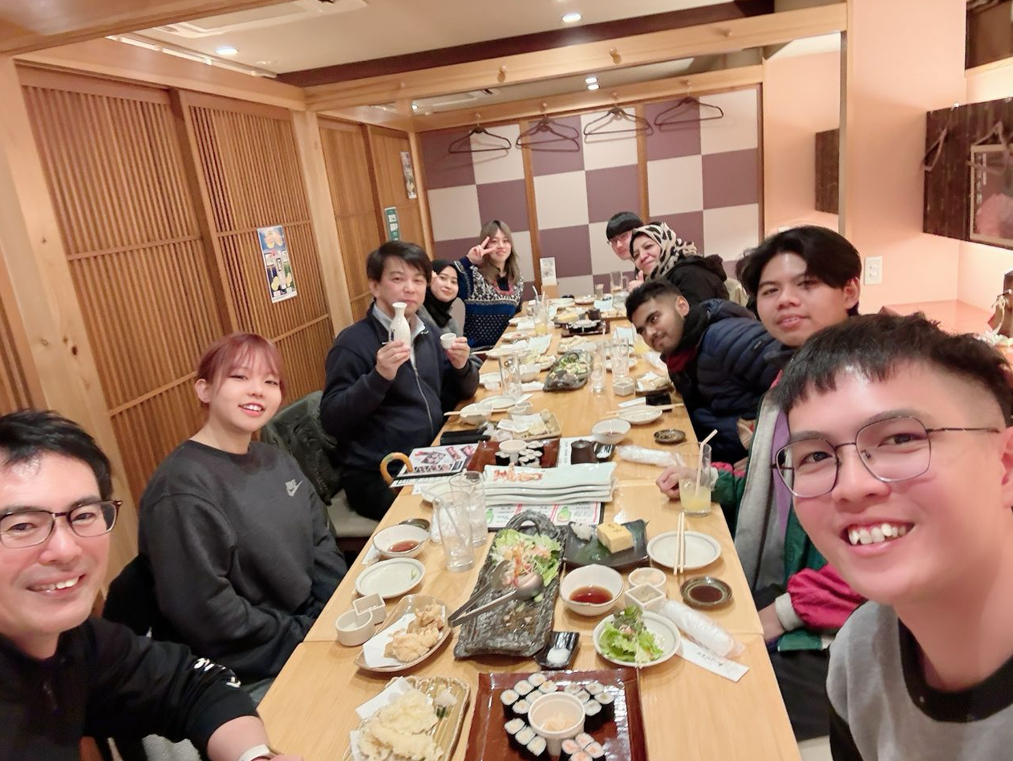
Welcome Party (Sushi Restaurant)

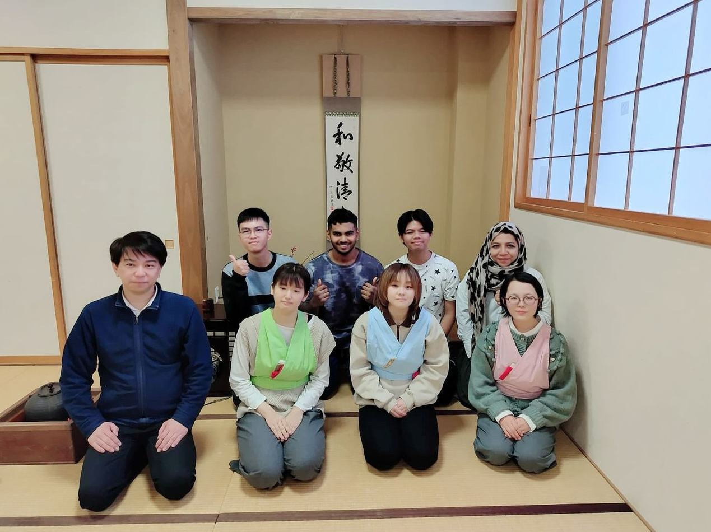
Cultures from Akita and Japan tea ceremony

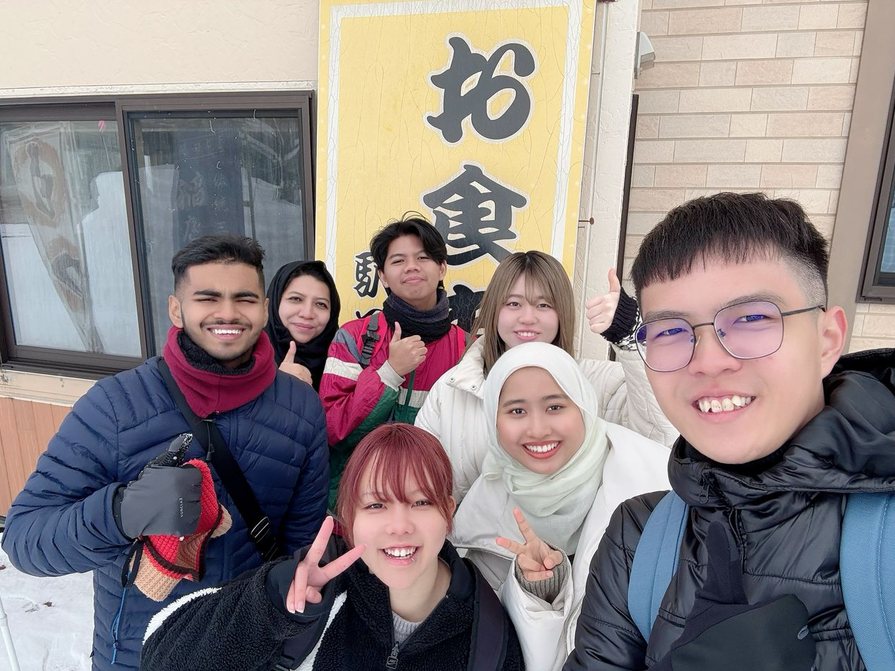
Tour to Hot spring with Akita students

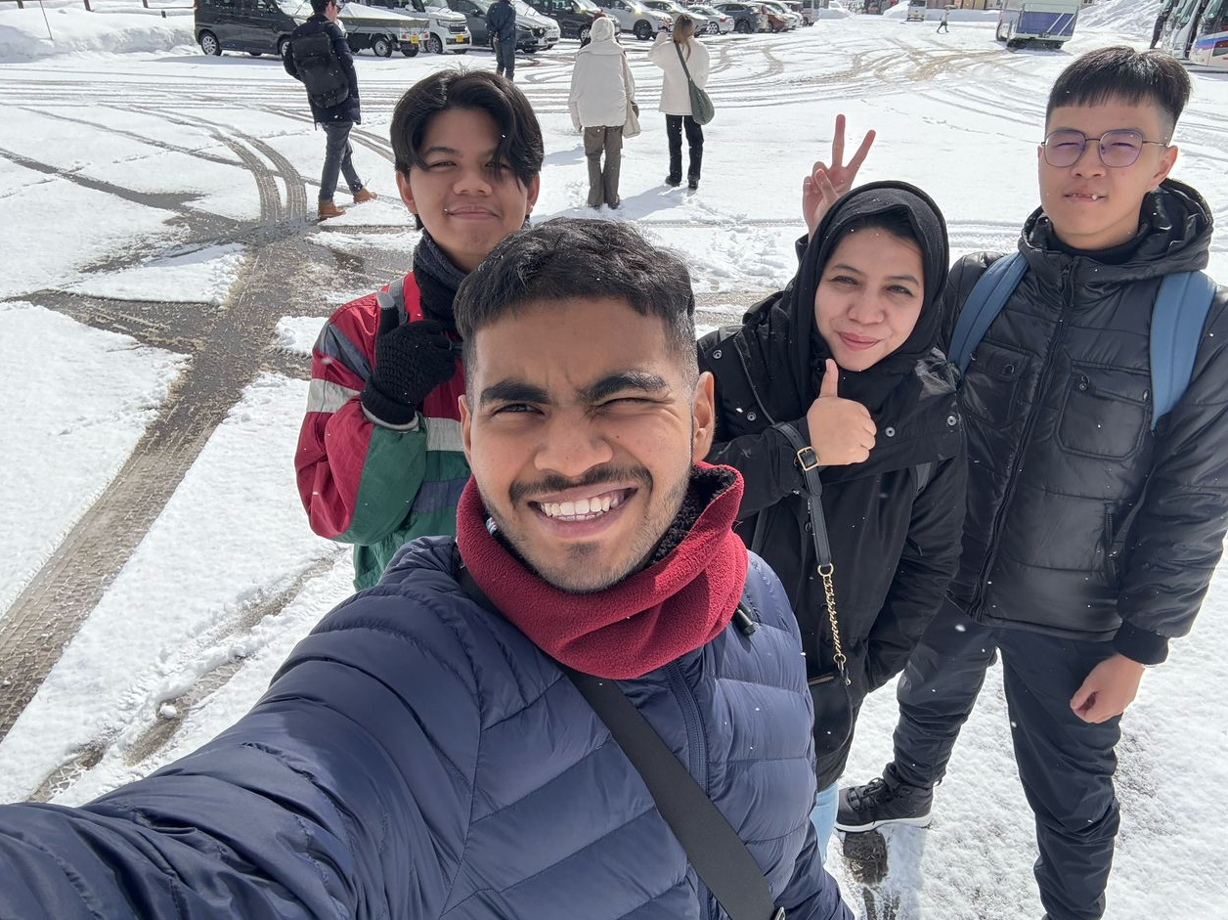
Tour to Tazawako lake at Akita Japan

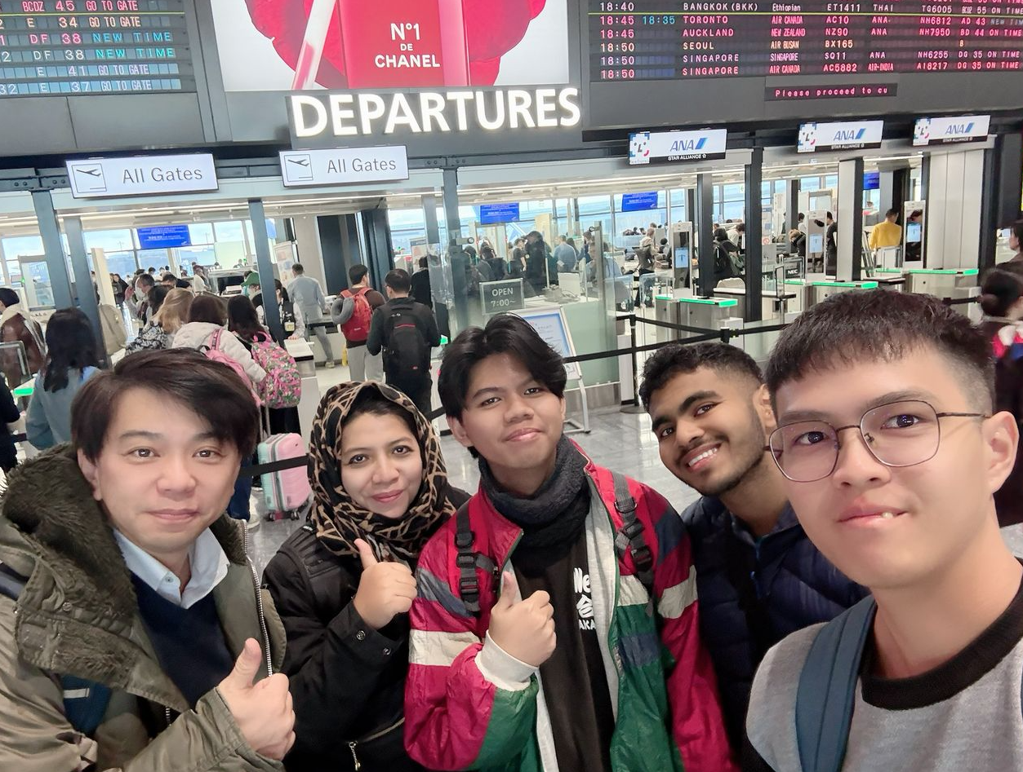
Departure from Akita Airport To Kuala Lumpur on 23rd February 2025

