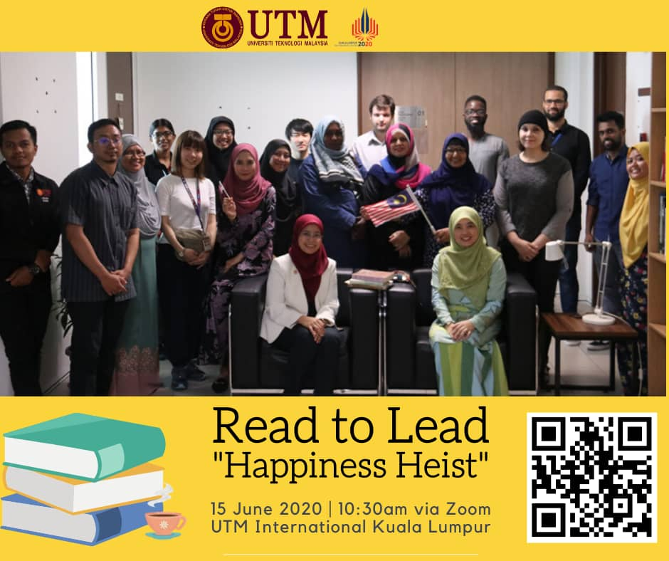

Kuala Lumpur, 15 June 2020 – UTM International Kuala Lumpur has successfully hosted the Read to Lead programme with the theme “Happiness Heist”. This sharing knowledge series are the first of such sessions to be carried out post COVID 19 pandemic and the importance to carry in with life positively in accordance to the new norms.
2 speakers had participated in sharing their knowledge that is Assoc. Prof. Dr. Norhayati Abdullah, Deputy Director UTM International KL and Madam Jamela Hanoon, the Vice President of ISSUTMKL.
The virtual sharing session has been getting great responses from UTM staff and International students. UTM International KL is looking forward to continue similar sessions with more inspiring themes in the future.

