CAREER OPPORTUNITIES FOSTERED AT FAIR ORGANIZED BY MJIIT

Kuala Lumpur, 11 April. – The Malaysia-Japan International Institute of Technology (MJIIT) organized their annual Universiti Teknologi Malaysia Kuala Lumpur (UTMKL) Career Fair on 11 April 2019 providing all especially the third and final year undergraduate students to explore recruitment options and to connect with potential companies offering employments.

The program which was officiated by Mr. Nik Nazmi bin Nik Ahmad, Member of the Parliament of Malaysia for Setiawangsa was also attended by Prof. Dr. Shamsul bin Sahibuddin, Pro-Vice Chancellor UTMKL and Professor Dr. Ali Selamat, Dean of MJIIT.

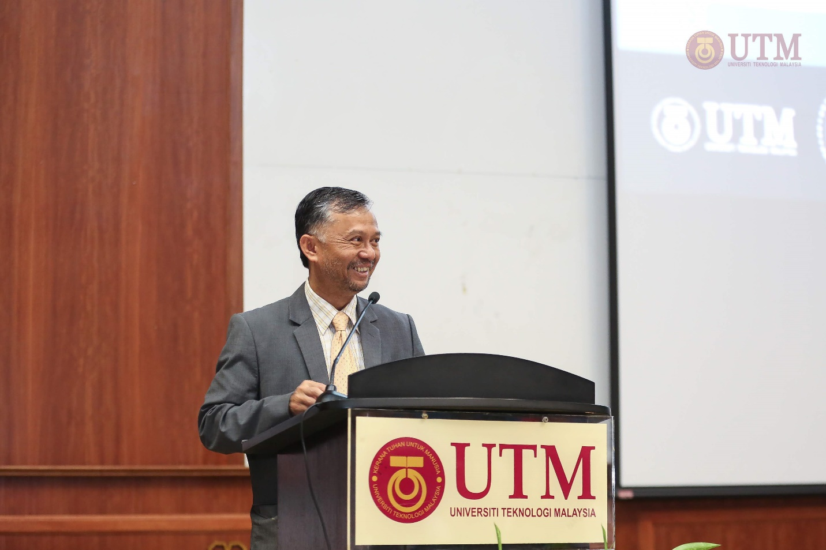
Pro-Vice Chancellor UTM Kuala Lumpur, Dr. Shamsul Sahibuddin is giving the welcoming speech.

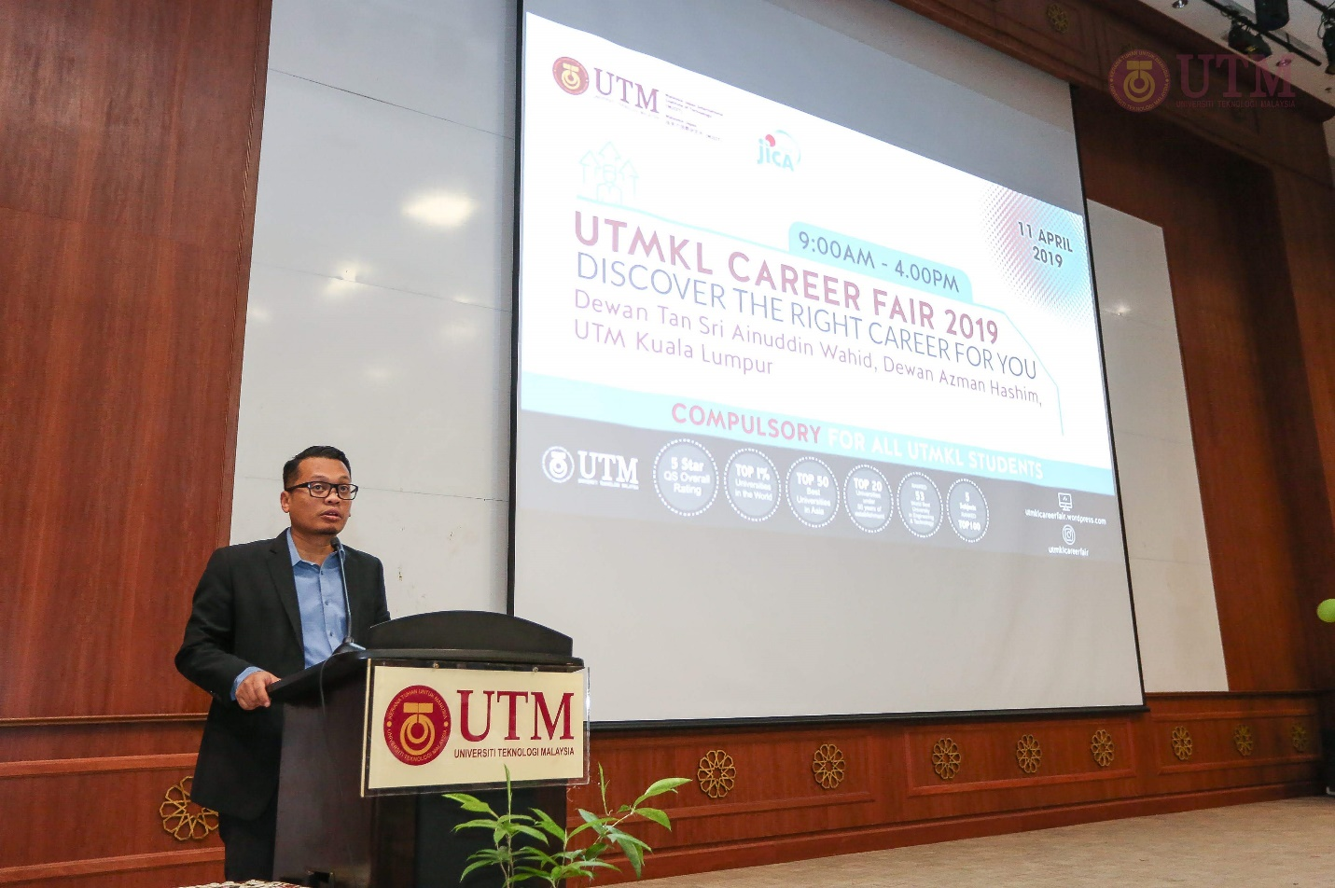
Member of the Parliament of Malaysia for Setiawangsa, Mr. Nik Nazmi bin Nik Ahmad delivering encouraging remarks prior launching of the program.

The program was complimented with an Inspiring Talk session by Ms. Irene Lock Sow Mei from Petronas Malaysia. Students get to listen and grasp her truly remarkable journey while being a Chemical Engineering student at Universiti Teknologi Petronas (UTP), where she was diagnosed with leukemia. With great support from family and close friends, she shared the story of how she managed to fight through the toughest times of her life.

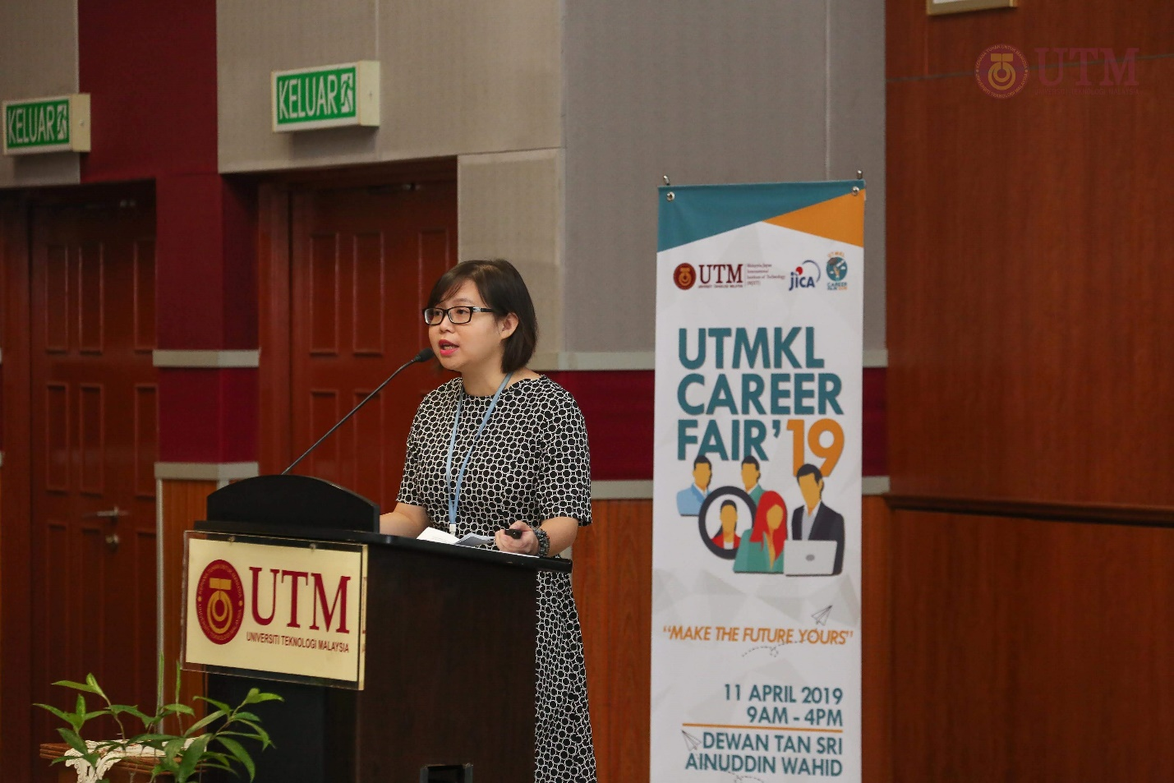
Ms. Irene Lock Sow Mei (Petronas Malaysia) delivered an inspiring talk with the title “A Rising Destiny; Success Through Hardship”, sharing her remarkable journey.

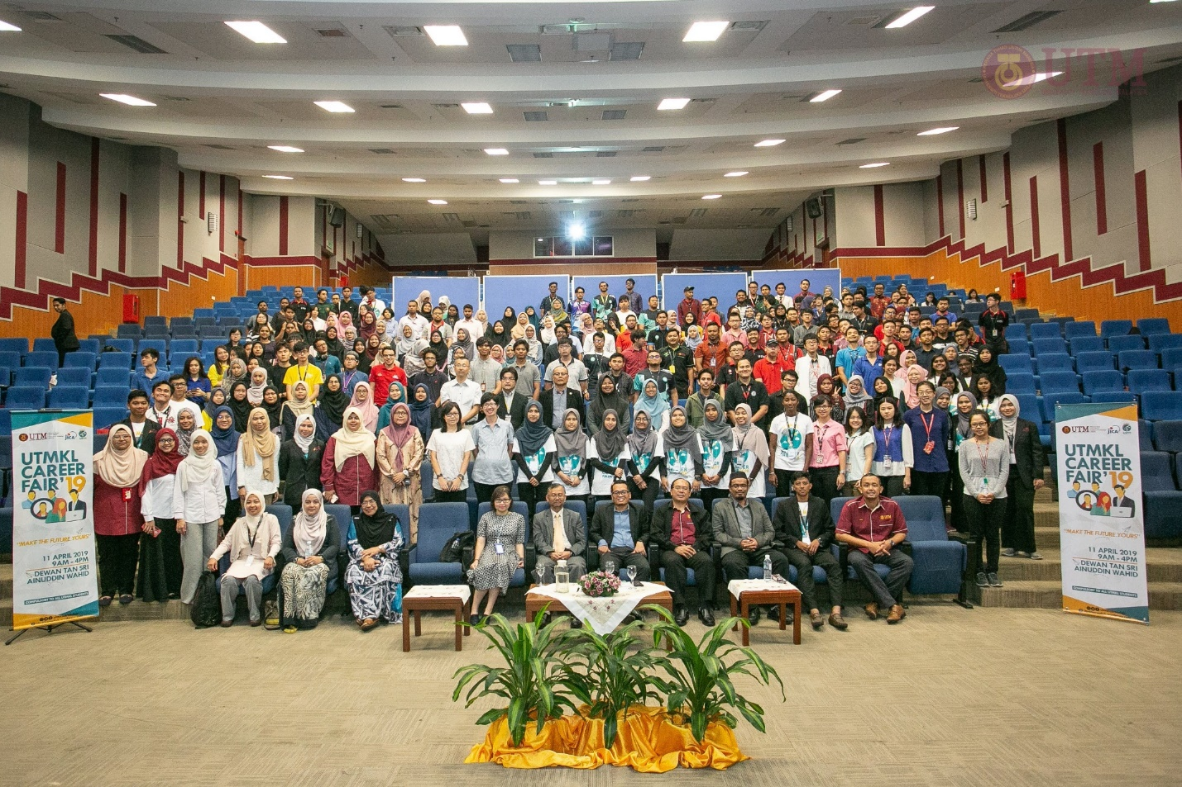
Group photo after the Opening ceremony and Inspiring Talk session.

At the Booth Exhibition, Exclusive sessions were arranged with a mixture of over 15 top-performing experienced engineering companies in a casual and engaging setting. Companies such as George Kent (M) Sdn. Bhd., Toray Group (M) Sdn. Bhd., Konica Minolta Business Technology (M) Sdn. Bhd., JAC Recruitment, Agensi Pekerjaan AN Asia Sdn. Bhd., Panasonic (M) Sdn. Bhd., Toyobo Textile (M) Sdn. Bhd., Rohm-Wako Electronics (M) Sdn. Bhd., NTT MSC Sdn. Bhd., Kesion Malaysia Sdn. Bhd., Tateyama Auto Machineco (M) Sdn. Bhd., Nippon Electric Glass (M) Sdn. Bhd., Yokowo Electronics (M) Sdn. Bhd., Hiro Food Packages Manufacturing Sdn. Bhd., Nabel Asia Sdn. Bhd., and Yamaha Electronics Manufacturing (M) Sdn. Bhd., were among prominent employers offering job prospects on-site at one of the key events for MJIIT UTM Kuala Lumpur this year.

Targeting the millennials as future leaders in the engineering industry, available job vacancies were advertised prior the scheduled event on Official UTMKL Career Fair social media platforms such as Facebook (@utmklcareerfair) and Instagram (@utmklcareerfair) whilst some companies advertised opportunities for industrial and training placements.

More than 800 students were reported to attend, consisting of Mechanical Precision Engineering (MPE), Electronic System Engineering (ESE) and Chemical Process Engineering (CPE) programmes of Malaysia-Japan International Institute of Technology (MJIIT) UTM Kuala Lumpur.

Furthermore, two HR Industrial Talk was held at Dewan Jumaah to further increase students’ knowledge on industrial and working experiences. The first talk was given by HR staffs from Konica Minolta, sharing their stories and privileges gained from working in the company. The Senior Director of Human Resource from McDonald’s Malaysia also came to give a talk on “What Employers Expect from Graduates”, sharing his thoughts and tips for future-ready graduates.

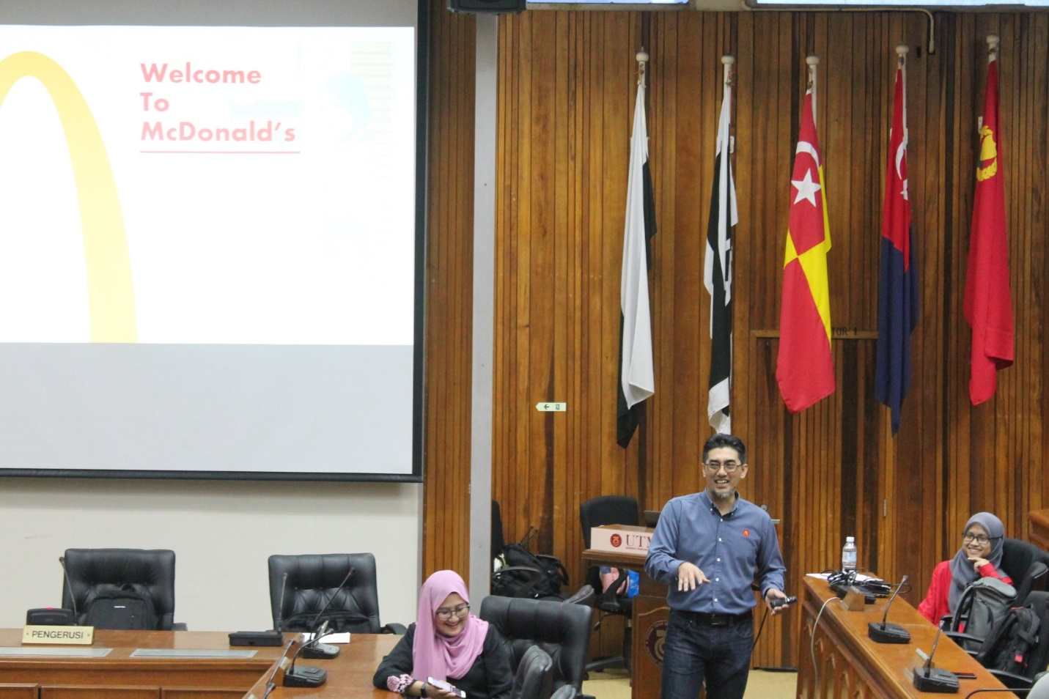
Senior Director of Human Resource from McDonald’s Malaysia gave a talk on “What Employers Expect from Graduates”.
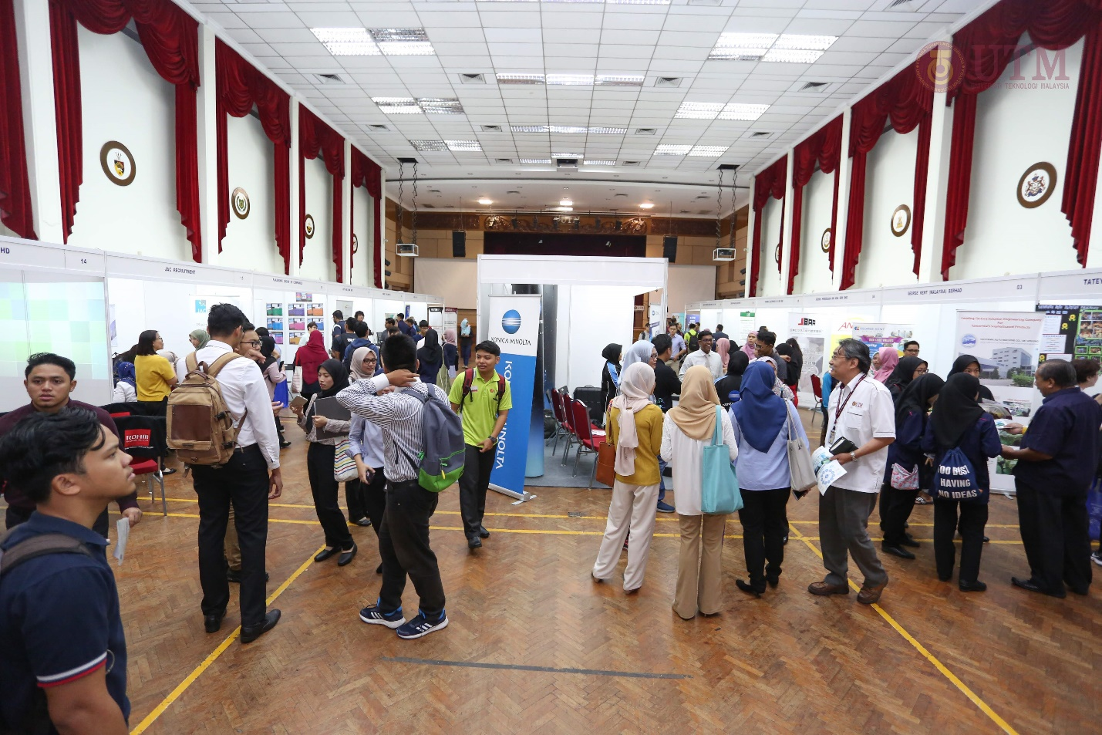
Students at the booth exhibition located in Dewan Tan Sri Ainuddin Wahid, UTM Kuala Lumpur.

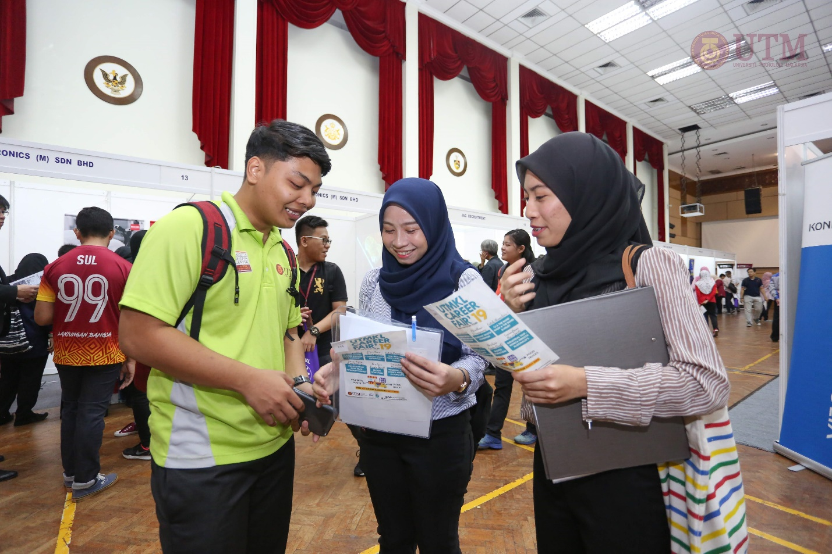
Undergraduate students are preparing their resumes for submission.

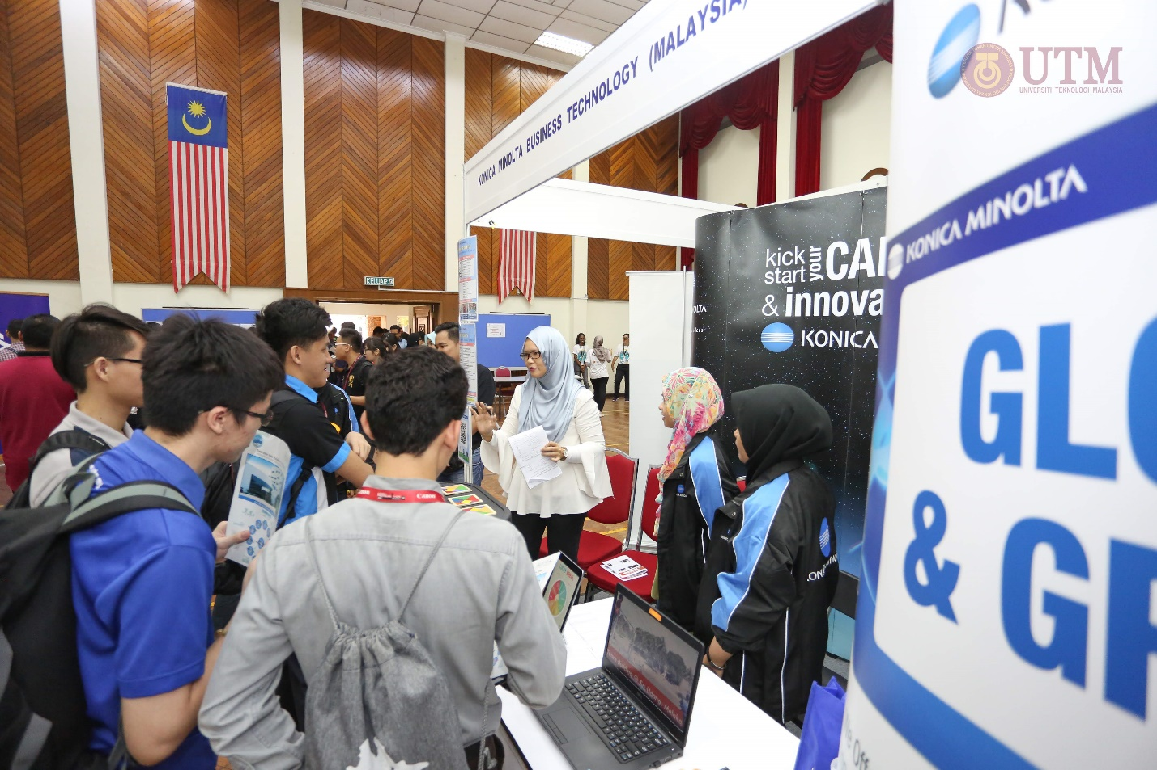
Students are engaging with the Human Resource personnel of the companies.

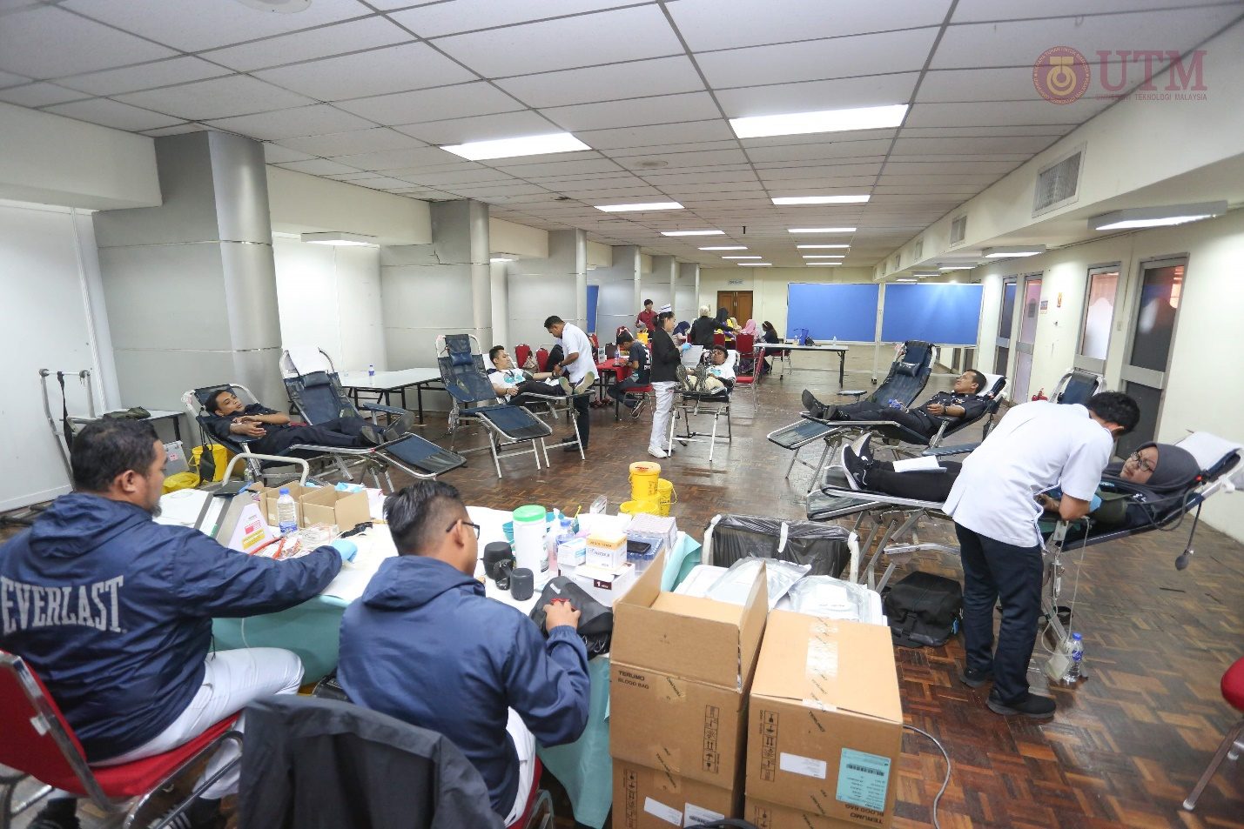
81 students and staffs are successfully donated their blood at the Blood Donation corner.

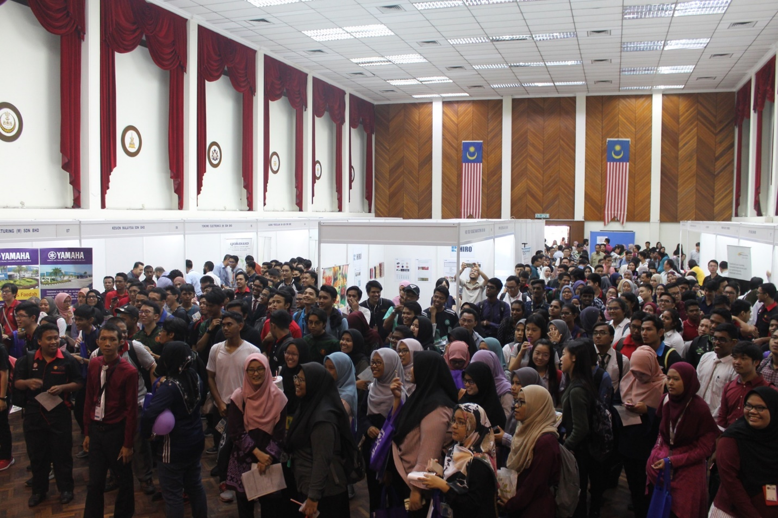
A big crowd of students are gathering for the exciting Lucky Draw prizes announcement.

The exhibitors were highly encouraged with the amount of audience they get during the event as students flooded the entire day’s program to engage with the company’s personnel, exploring company’s expectations and career opportunities.

